Vision for Trinity Membership Records
E. Lynn McLarty August 2025

In the early 1990’s and amid my genealogical travels to many libraries throughout Florida, Georgia, and Alabama (much, much before the availability of information on family history websites), and finding indexed books on a community church’s history, the thought occurred to me to pursue the possibility of organizing Trinity’s old records in a format readily accessible to other family history enthusiasts.

A long-time member of Trinity, a founding member of the Tallahassee Genealogical Society, and a resource person in my early years of genealogical research, Nellie Bird Mims supported me wholeheartedly on my idea for Trinity’s records. With Nellie’s encouragement I made mention of my broad plan to the co-chairpersons of Trinity’s Church History Committee Vernon and Jamie Parramore.

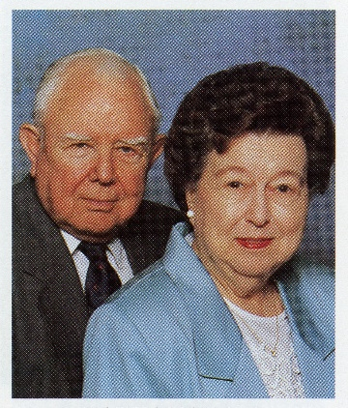
On a Friday morning within the next few weeks, I experienced an “awakening” when Vernon and Jamie Parramore introduced me to the membership books. From the very small room in the hallway adjacent to the church parlor, they brought me a special treasure. I was holding in my lap for the first time one of our very old church membership records. I sat in awe as they explained what profound meaning these records hold for Trinity history. It did not take long before I could readily see that the varied information on each Trinity individual would be a treasure to any genealogist. There were names, baptism dates, marriage dates, and death dates. In some later books the place of residence of the family was included. Some membership books named an individual’s former church before coming to Trinity as well as the name of the new church and city when the congregant member moved their membership from Trinity.

After this Friday morning experience my mind began to visualize the creation of a digital replication of this most-important resource of Trinity’s past. I was impressed how all the entries in the membership books followed the same general format—rows and columns. These membership books were stock items purchased with the sole intent for churches to record their membership rolls.

My immediate endeavor was to search for available computer software which would allow a spreadsheet design, a single entry of data, and allow easy manipulation of this data to accommodate future changes in formatting. After consultation with many individuals who used spreadsheets for their business, the preponderance of recommendations directed me to the Microsoft product Excel. I had found my program for the project. During this time of my making these logistical decisions, the Parramore’s were gaining the support for my work from the Preservation of Church History Committee and from the Senior Minister David Hortin. The year was about 1993.

Once given the approval to proceed, the first item to undertake was to photocopy the contents of Book 1. I spent many Friday mornings in the Church office (under the tutelage of the staff secretaries’ showing me the intricacies of their sophisticated photocopier) meticulously copying the pages from Book 1. One must remember the delicacy of handling this book and the care that had to be taken to ensure the book’s integrity while turning it upside down for the photocopying process. All the pages were tattered, some to the point of being brittle. The pages of photocopied material were then hole-punched and bound.

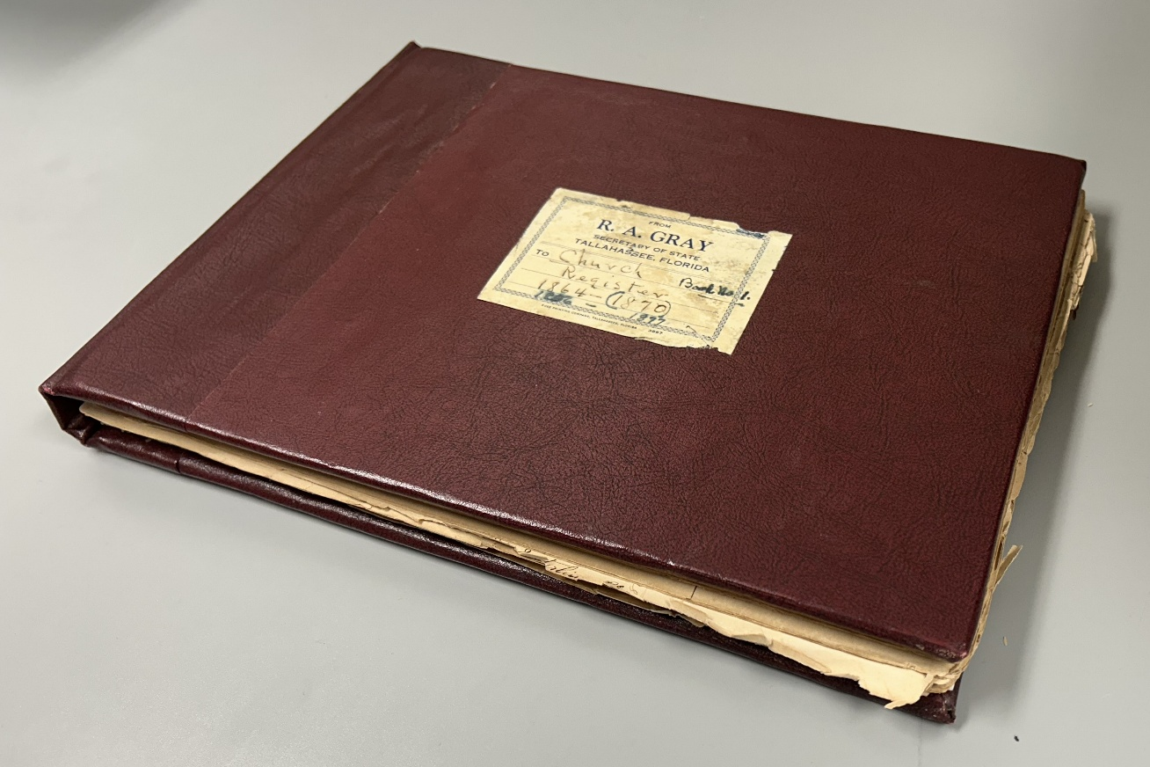
Book 1

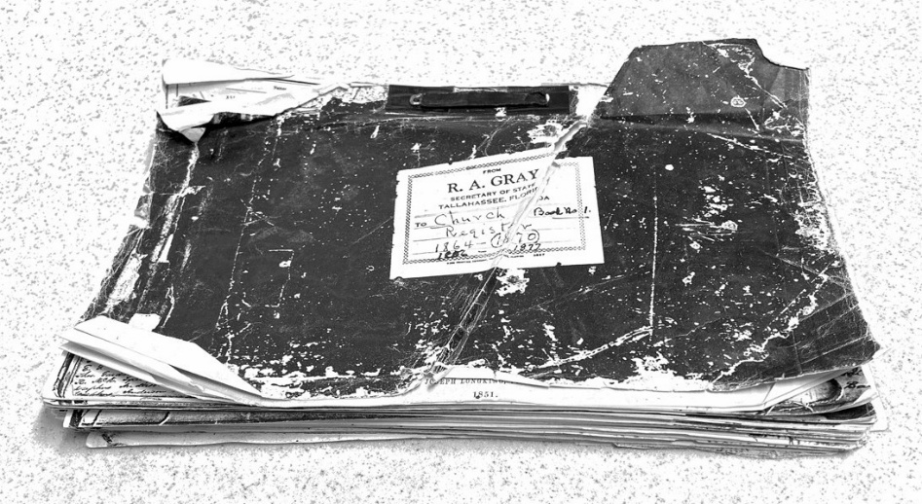
Book 1 photocopy for home use in transcribing.
Photocopying Book 1 afforded three benefits:
1) it gave me a copy of the book to use at home making entries onto the computer, on my time without having to be at the Church.
2) it allowed for minimum handling of the original book during the time of data entry.
3) it gave the Church another copy of this most important treasure in case the Book becomes misplaced or destroyed.

During the next year of entering data into the self-generated template, the Excel file slowly paralleled Book 1’s format. What pride to see the progress. Once the contents of Book 1 had been entered into the realm of the “digital age”, Book 2 was approached in the same manner as described. Book 3, Book 4, Book 5, and the Book of the Boulevard Church Mission were methodically photocopied for my use at home at the appropriate time. All the Books were different, and this required the creation of a new Excel template for each one. All the work at home remained on my computer, being backed up to diskettes.

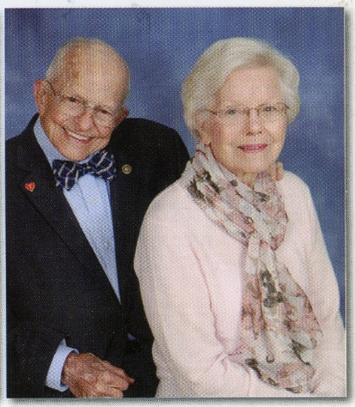
In about 2003 Linda and Bob Yates became co-chairs of the Preservation of Church History Committee. Linda and Bob were constant motivators for me to continue this project. From
Linda’s gentle and soft voice would frequently come the query “Lynn, how are the membership books coming?” Not knowing the vastness of the capabilities of the internet, it was my intention to have the books put into print for dissemination to libraries, to state archives, and to private homes. At that time, I envisioned that each book, or a compilation of the entire array of books, was to be a purchasable item, maybe a money-making project for the youth or some other Trinity related group. Linda and I discussed many times how the membership books should be available to others outside our own Trinity.

Only with the proliferation of the world-wide web and its ability to distribute information exponentially beyond the walls of a public library did I start thinking of preparing my work for a Trinity website or for a website under the auspices of the Tallahassee Genealogical Society. The search for a person with computer software knowledge of how to take my project and adapt it to the Internet was a slow process. Internet protocol constantly changed and expanded in dynamics and use. It seemed the internet was too new for most individuals to offer help. There was hope that this unique individual would be imminently forthcoming. Comparing the transcribed pages to the original book, I began looking at my work with intense scrutiny. I found the transcribed pages were less than perfect—so many questions regarding my deciphering ability.

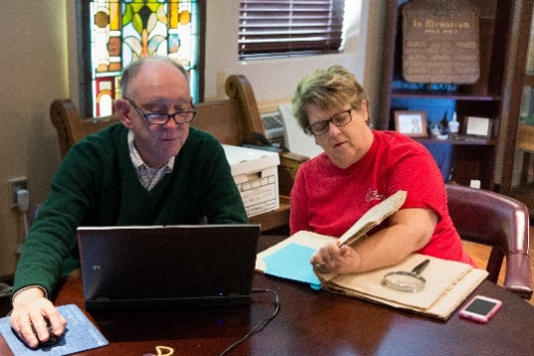
What I needed was a partner who could be generous with her time, to work closely with me to edit my work regarding spelling, formatting, and deciphering handwritten entries. In 2010 Judy Tait Levy offered to sit with me one afternoon and let me show her my work in transcribing Trinity’s membership records, particularly Book 1. As a long-standing Tallahassee resident, she immediately became interested in the names, the dates, and the association of Trinity’s history with present-day Tallahassee. From that moment on, her unwavering commitment was so valuable. She not only was being the chairside auditor of the prevailing book, but she constantly offered suggestions to enhance the membership book project.

The auditing process was a protocol I established to compare the original source of the material (the Membership Book itself) to transcribed data on the laptop computer’s Excel template. The work was tedious, but I knew with confidence the entries had been under a second scrutiny. When we had three membership books audited, we became more interested in finding someone with the unique computer skills to put our databases into a printable format. Having our work placed online was so removed from our thinking. It was in the summer of 2014 that Judy and I were introduced to the third member of our team--that long-sought person with the knowledge and the dedication to working alongside us to make these books possibly an internet reality.

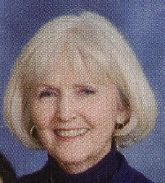
Colleen McConnell was, without question, the answer to my prayer for this
project to go from a static computer database to our dream of Trinity’s
membership records available to the world. With Colleen’s computer
abilities, the databases were transformed in the fall of 2014 into an easy-to-use searchable format for online use. Having the membership books online and “searchable” were the paramount factors in dismissing the idea of the project’s being published as printed books.

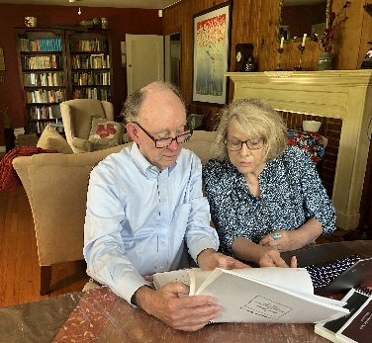
As Colleen found she could no longer give the time she had once dedicated, Pam Crosby arrived as her stead. Pam’s unique abilities to manipulate the Excel data and transform the raw material into the format for the online presentation brought a seamless continuity to the project. Trinity’s first five Membership Books and the Boulevard Church Membership Book became exposed to the public by way of the church’s internet site. There were five more books to be transcribed and audited. Up to this stage all the transcribing had been done onto my computer at home with Judy and my having done all the auditing. After much discussion, and with Pam’s support, there was a change of direction in putting the membership books online. Pam encouraged me to revise my protocol and to complete sections of Books. She would then place the completed section online, knowing when the entire Book was completed, she could reformat the databases and replace the earlier material with the Book in its entirety. This would give immediate online exposure of selected sections of these last Books. By 2020, completed sections for Books 7, 8, and 9 were intermittently given to Pam and they were entered online. With this new direction, I began to search for others who could contribute to the project by transcribing from my photocopies of the remaining books.
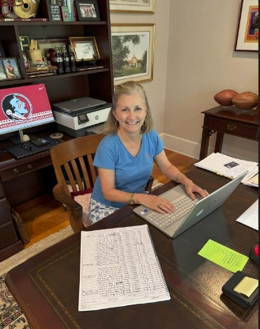
The expansion of contributors to the Membership Book project produced profound results. It was in 2016 that Amy Henderson’s immediate positive response to my talking to her in our Sunday School class that opened the door for her involvement. Beyond several meetings to explain the transcription process and to give her the photocopied material, her computer work did not require meetings at the Church. She worked at her pace and in her environment. Once her completed entries into Excel reached my computer, the database was organized, and the auditing process began. There was never a request to Amy for her to transcribe another section that she gave a negative response.

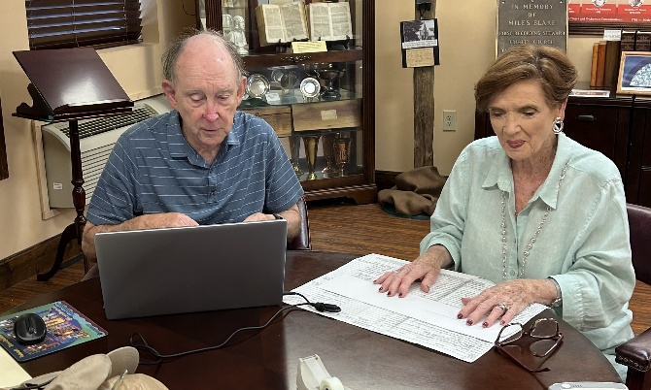
Judy moved from Tallahassee in 2021 and after a relatively short time I found another Tallahassee-born, Trinity-member Earline Welch Adkison to take over her position. Book 8 and 9’s auditing lay before us. As she took Judy’s chair at our round table in the Yates Center, Earline quickly discovered she was finding so many familiar names from her past. As Earline and I struggled to make modest progress in auditing the very comprehensive Chronology by Alphabet section of Book 8, it came to me that, if I had more chairside auditors, I could have several auditing sections taking place during the week. The end of the project was in sight, but more intense work would be required.

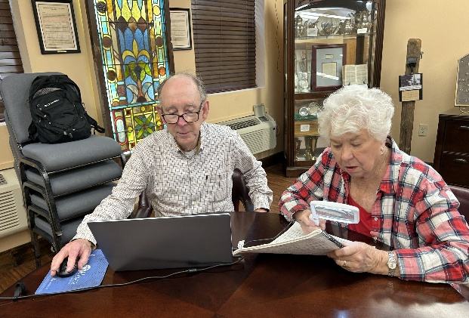
Working alongside Cecile Williamson Baker in the last few years in other projects for Trinity’s archives, she could sense my desire to put more time and energy into the completion of the membership book project. There were six or seven sections of the final two books (8 and 9) that needed auditing. She knew that Book 10 had a unique set of circumstances for transcribing and auditing (See Book 10 Explanation) since it had been generated from computer sources rather than from a written membership book. Her offer to help with auditing several sections of Books 8 and 9 and then immersing herself completely by helping put Book 10 in electronic format was very fortuitous for the project.

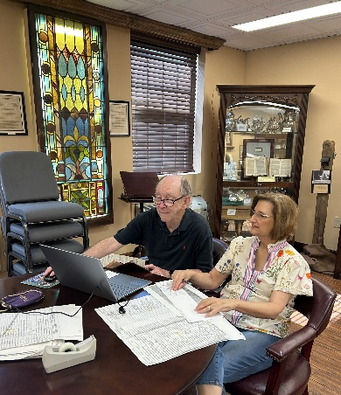

In May and June of this year Cindy McDuffie shared her talent as
a chairside auditor, giving the verification to the final two sections of the membership books project. Finally! Now came my preparation of the remaining three books in their entirety into pdf’s to be given to Pam for placing online. But before this could be finalized came the following unexpected news!

In June 2025 the church staff informed the Committee for the Preservation of Church History and the Trinity Historical Society that the church was in the process of upgrading the software for all their computers. Concomitant with the church’s expansion of its programs and needing more space on the website, the church procured a separate website for Trinity’s online historical records. In July all the present historical records were removed from the present tumct.org domain and placed on the new website www.tumcthistory.org. From the very beginning, Pam Crosby took the position as webmaster for the new historical site and represented the interests of disseminating Trinity’s history via this medium.

When it came to my knowledge of our church historians’ having our own site to stage Trinity’s history, I immediately had in mind to improve the presentation of the membership books section. Adding documents through the years has had the same format as at the beginning in 2014. I wanted to give to the congregation and to the public a more thorough assessment of each membership book. One will now find more information in the Explanation segment for each Book. Adding this Vision to the new website also has given me the opportunity to share with the congregation how this long, drawn-out project has become such a vital addition to Trinity’s records reaching far beyond the walls of the Church. It is with sincere appreciation that I laud those now-deceased individuals who introduced me to the membership records and who encouraged me to accomplish transcribing the registers. To my wife Miriam and our three daughters Emily, Rebecca, and Margaret, thank you for supporting me during these thirty years of the project. To Judy, Colleen, Pam, Amy, Earline, Cecile, and Cindy, you individuals who have worked with me so intently, and for the many, many hours you have given to have these special records online in this remarkable format, I thank you so very much.

E. Lynn McLarty
August 2025

